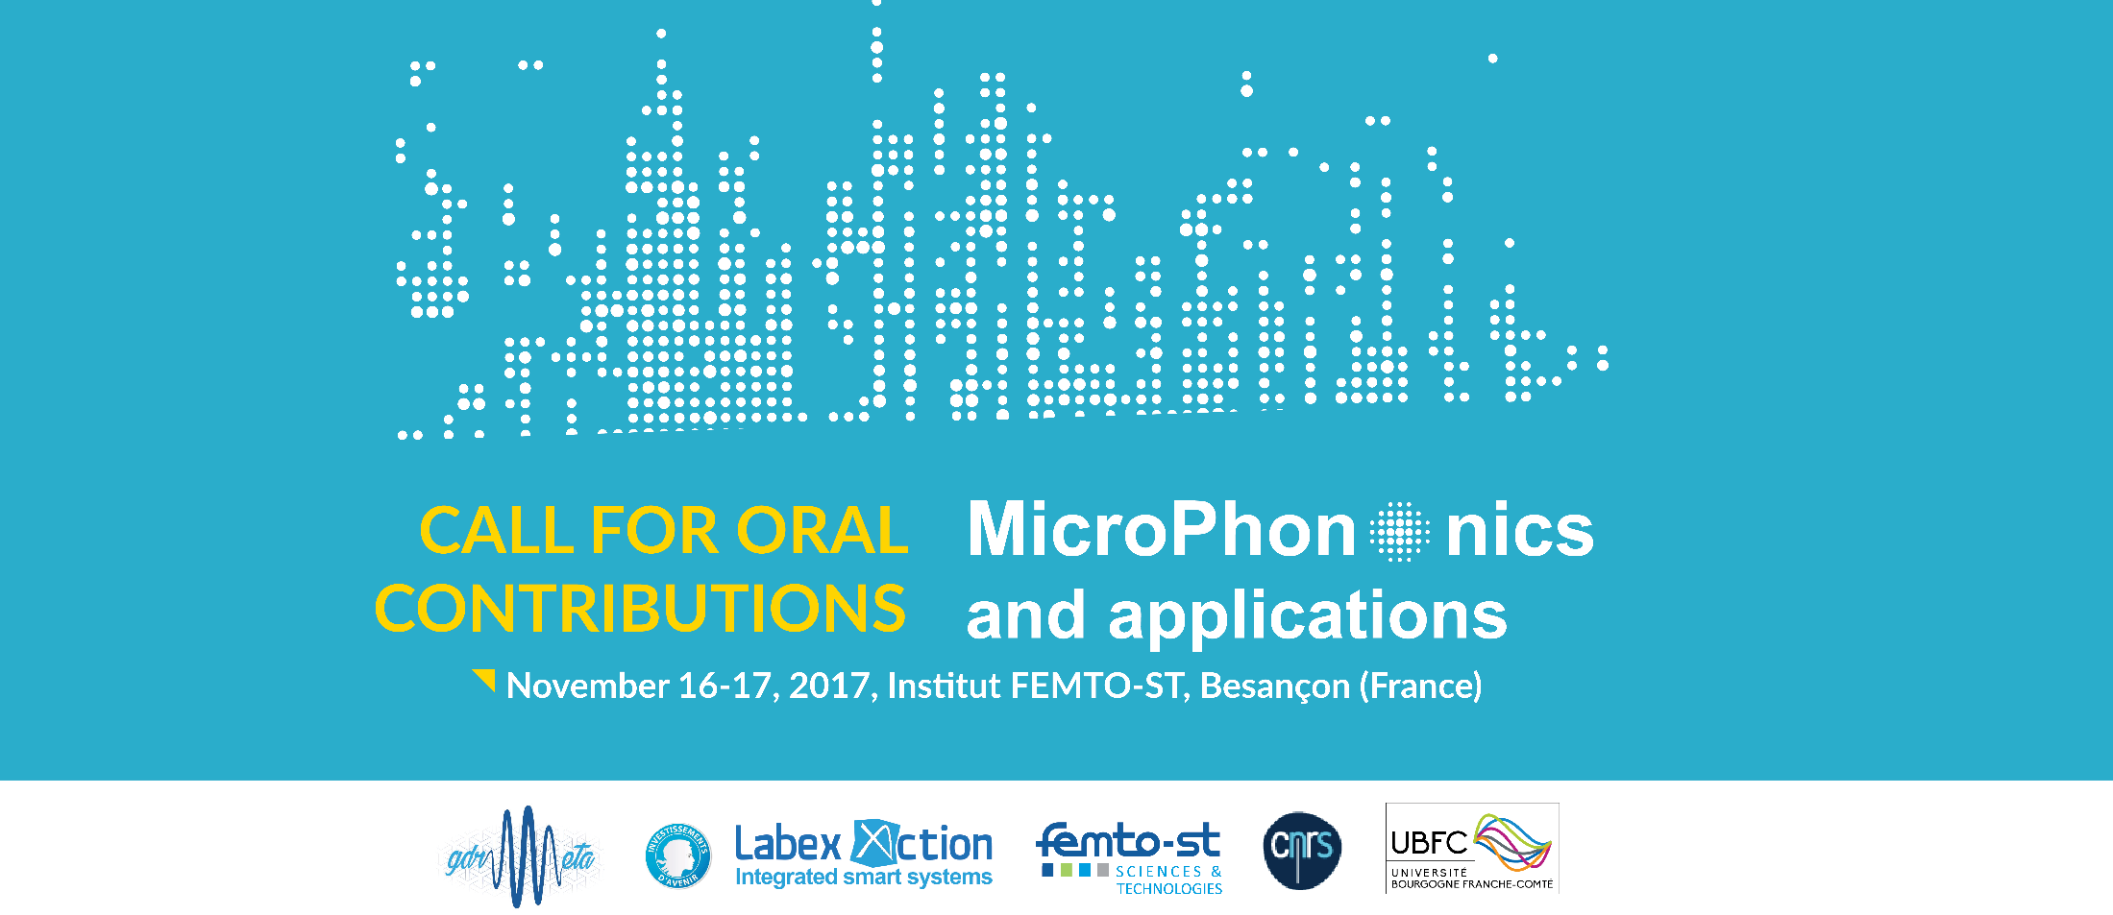
MicroPho

Call for contributed oral and poster presentations

Submit papers
Questions regarding the abstract submission can be directed to the Organising Committee at phononics2017@femto-st.fr at any time.

Author Timeline
Call for Abstracts Opens | September 2017
Abstract Deadline | October 9, 2017
Primary Author Notifications email | October 16 2017

Requirements:

Abstracts may be submitted for oral or poster presentation; the final decision will be made by the committee.

All content, including drawings, charts, photographs, tables, figures, and references should be within the specified 1-page limit according to the style guide provided below

It is the responsibility of the author to get all internal reviews and institution approvals prior submission.

If your paper is accepted, your abstract will be included in the short conference Program.

Style guide and language

The 1-page manuscript should be submitted electronically in .doc or .pdf by using the application form below.

Page size is A4 format (210 mm x 297 mm) and paragraph is typed in single-space. All content, including drawings, charts, photographs, tables, figures, and references should be within the specified 1-page limit.

All submissions must be in English.

For detailed style guide and standard manuscript template (.doc template or Latex style file), please download the MSword Manuscript Template (.doc)

The use of LaTex is possible but make sure the page layout is respected as for the MSword template.

Important Information about Preparing your Paper: The quality of your PDF file is important as the paper will be published in the workshop booklet if accepted. Please verify carefully the quality of your manuscript for print and electronic publishing.

Information for oral papers:

All oral papers are 15 minutes, including discussion.

The following presentation equipment is available: overhead projector, laptop, laser pointer.

Information for posters:

Posters boards are 1.4 m high by 1 m wide.

Posters are planned to be left up before 9.30am on November 16, 2017.

Materials for mounting posters will be provided.

Selection and notification process
The selection of papers for either oral or poster presentation will be made by the program committee after consideration of their abstracts.
Only primary authors on poster/oral contributions will be notified (by email) of their abstract's acceptance or rejection on October 16, 2017.

Abstract Submission

The submittal system will remain until 9 oct, 2017.

By submitting an abstract, each author agrees to present the accepted contribution (oral or poster) and to register to the event (one registration is required for each accepted paper).

Submit an abstract

First Name *
Last Name *
Organization
e-mail address *
Title of Abstract *

Attach Your File *

Files must be less than 2 MB.
Allowed file types: .doc, pdf.

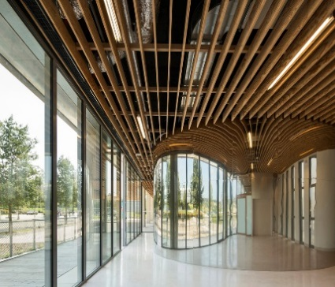
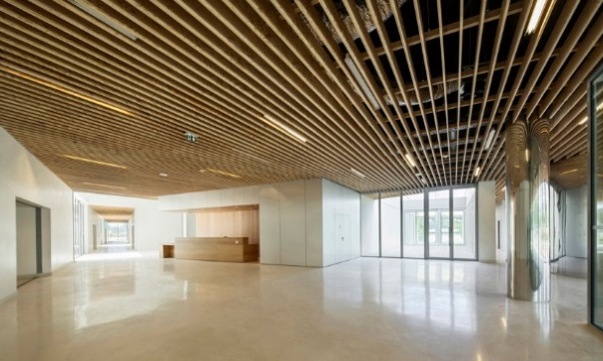
Poster session area

TITLE
Author 1, Author 2…
Affiliations
e-mails

Here insert a brief account of the most relevant aspects and main findings of the reported research (2 or 3 lines).

Description

Fig. 1: legend

Keywords: at least two keywords must be provided.
References
[1] Author name, publication name, journal, year of publication
[2] P. Russell, “Photonic crystal fibers.,” Science, vol. 299, no. 5605, pp. 358–362, (2003).

