Title
Author #1 ¹, Author #2 ¹, Author #3 ²…

¹Affiliation
²Affiliation

Abstract
Ten to twenty lines is enough. Figures & references are optional. Maximum 1 page.

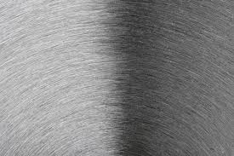
Figure 1 : Caption | Figure 2 : Caption

References
A. AuthorA, B. AuthorB, “Hydrogen for all”, Journal of Great Events, 12 (2014) 15-99.

